Project Name: Pendulum

Experimentalist: Mr. Eitan Segev

Technical Support: Dr. Lior Segev

Date: Wednesday, October 6, 2021

**Research Questions:**

1. What is the dependence between the pendulum period and its
   1. Length?
   2. Amplitude (angle of attack)?
   3. Mass?
   4. Aerodynamic shape?

**Experimental Setup and Methods**

In Figure 1, Pendulum system is shown. Its main components are the mass, string, the points in which it is attached to two poles. In Figure 2, we point out important electronics sensor related information. The detection of the mass is made by an IR LED and sensor combination. When the mass breaks the IR beam and prevents it from reaching the IR sensor a signal is sent to the microcontroller. The microcontroller then reports back to computer the exact time stamp in which the mass was detected by the sensor.



Figure - Pendulum principal components



Figure - Top view. The microcontroller communicates to the computer the time in which the pendulum mass broke the Infrared beam

**Experiment Number 00001**

We pull the mass back and release it. The computer saves the timestamps for which the mass enters the IR beam and leaves it.

1. Mass weight is: ____ kg
2. The mass is perpendicular to the table
3. String length:
   1. String 1 is 0.08 ± 0.005 meters
   2. String 2 is 0.075 ± 0.005 meters
   3. The height from the mass to the contact point in perpendicular line is 0.07 meters ± 0.002 meters
4. Angle between the strings is:
   1. Between string 1 and a perpendicular line to the mass is 35 ± 10 deg
   2. Between string 2 and a perpendicular line to the mass is 45 ± 10 deg
5. Mass width: 0.022 ± 0.001 meters

**The raw data**

Useable data is in files 00001_04 – 00001_09 in folder Pendulum_Eitan_Project

Typical raw data file looks like this:

I Experiment name: run_task

I Task name: example/IR

I Task file hash: 1034384289

I Setup ID: /dev/cu.usbmodem207E367458531

I Subject ID: 00001_04

I Start date: 2021/10/05 18:36:43

S {"OBJECT_IN": 1, "OBJECT_OUT": 2}

E {"object_in_beam": 3, "object_out_beam": 4}

D 0 2

D 674 3

D 674 1

D 693 4

D 693 2

D 971 3

D 971 1

D 994 4

D 994 2

D 1264 3

D 1264 1

In the first column the letter D signifies data.

Second column is the time in ms from experiment start time.

Third column is the index of the state or event.

Possible states are: “OBJECT_IN” is the number 1, “OBJECT_OUT” is the number 2.

Possible events are: “ object_in_beam” is the number 3, “object_out_beam” is the number 4.

Figure presenting typical raw data:

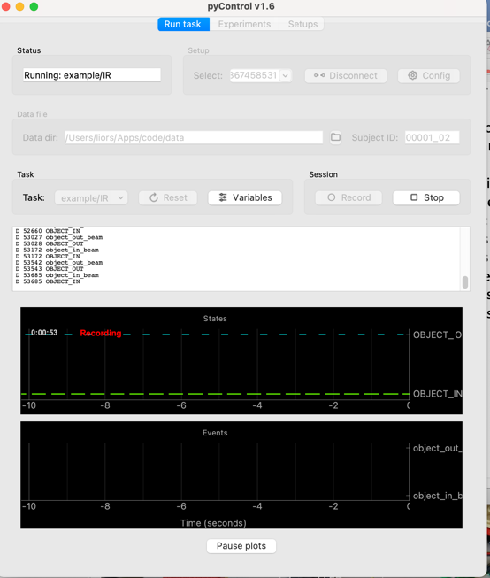

Figure - Typical raw data where “OBJECT_IN” state means that the mass broke the IR beam

**Experiment 00002**

In experiment 00002 we change the mass release angle. We measure the mass speed as a function of the release angle.

1. Mass weight is: ____ kg
2. The mass is perpendicular to the table
3. String length:
   1. String 1 is 0.08 ± 0.005 meters
   2. String 2 is 0.075 ± 0.005 meters
   3. The height from the mass to the contact point in perpendicular line is 0.07 meters ± 0.002 meters
4. Angle between the strings is:
   1. Between string 1 and a perpendicular line to the mass is 35 ± 10 deg
   2. Between string 2 and a perpendicular line to the mass is 45 ± 10 deg
5. Mass width: 0.017 ± 0.001 meters

**Data Analysis**

To find the pendulum period we calculate the difference between two non-consecutive “OBJECT_IN” states. In Figure 4, we present the period of pendulum in milliseconds as a function of period cycle. The cycles count is a simple counter of the pendulum as it goes from one full oscillation to the next.

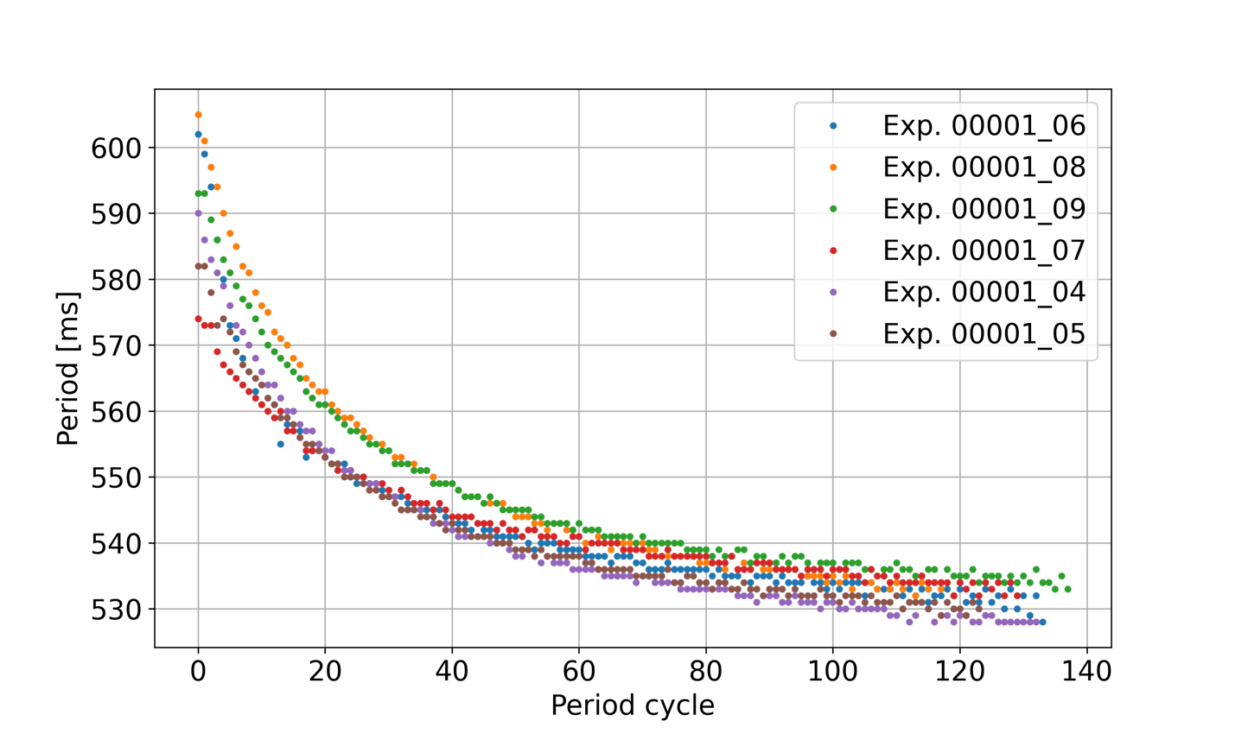

Figure - Pendulum period as a function of period cycle

We find that as the pendulum swing starts from an angle of about XXX deg the period is at its highest and is between 570-620 ms. As the pendulum loses momentum due to friction in its contact points the period starts to decay and after 100 cycles it stabilizes to values between 530-540 ms.

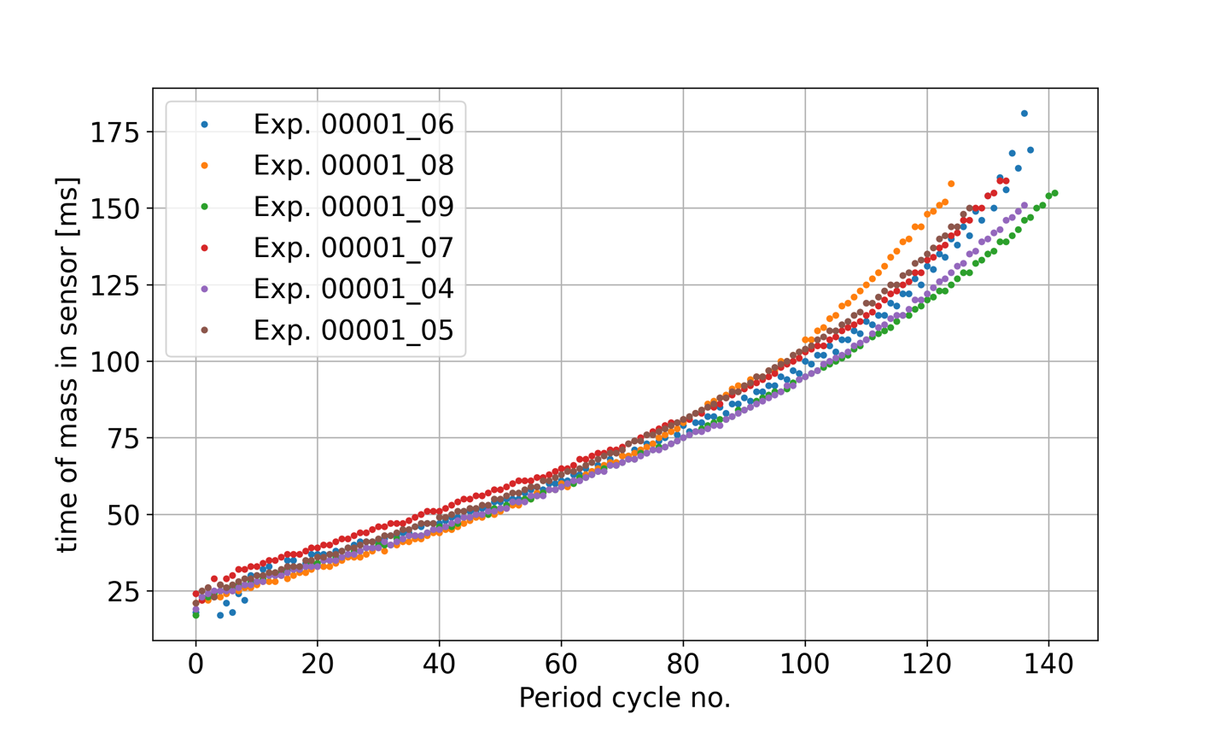

Figure - the time the mass spent in the sensor as function of Period cycle no.

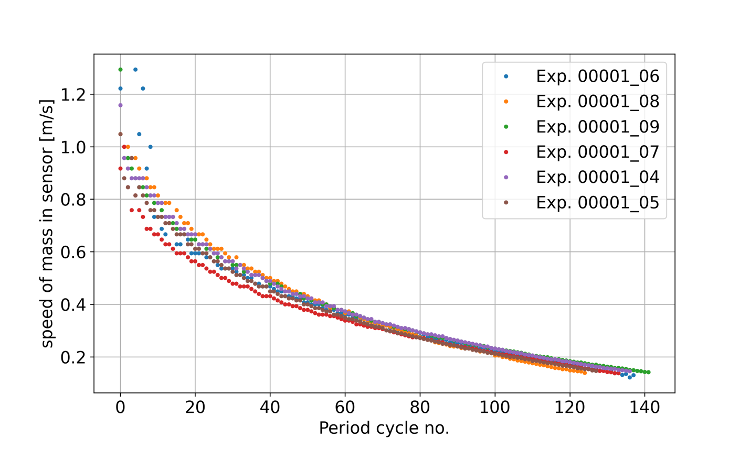

Figure - Mass speed as function of period cycle

|  |  |  |
| --- | --- | --- |
| Experiment number | Angle of attack [deg] (independent variable) | Period [ms] (dependent variable) |
| 00002_01 | 60 | 533 |
| 00002_02 | 60 | 529 |
| 00002_03 | 70 | 538 |
| 00002_04 | 70 | 540 |
| 00002_05 | 80 | 555 |
| 00002_06 | 80 | 549 |
| 00002_08 | 90 | 555 |
| 00002_09 | 100 | 566 |
| 00002_10 | 100 | 580 |
| 00002_11 | 20 | 525 |
| 00002_12 | 20 | 521 |
| 00002_13 | 30 | 530 |
| 00002_14 | 30 | 523 |
| 00002_15 | 40 | 528 |
| 00002_16 | 40 | 526 |



Figure - Period as a function of angle of attack

**Speed of the mass related to the angle of attack**

|  |  |  |
| --- | --- | --- |
| Angle of release [deg] | Speed [average] | Period [s] |
| 20 | 0.12979351 | 0.523 |
| 30 | 0.3697479 | 0.5265 |
| 40 | 0.45360825 | 0.527 |
| 60 | 0.63768116 | 0.531 |
| 70 | 0.77192982 | 0.539 |
| 80 | 1.12820513 | 0.552 |
| 90 | 1.04761905 | 0.555 |
| 100 | 1.375 | 0.573 |

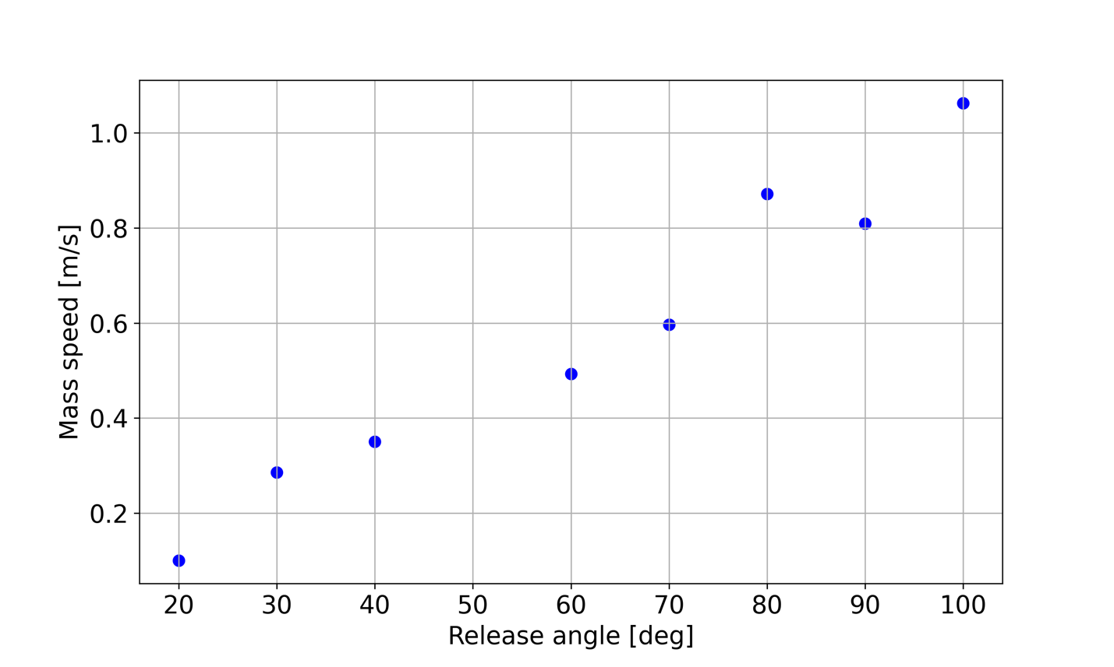

Figure - Mass speed as a function of release angle

**Experiment 00003**

In experiment 00003 we measure the period as a function of the string length.

1. Mass weight is: ____ kg
2. The mass is perpendicular to the table
3. String length:
   1. String 1 is 0.08 ± 0.005 meters
   2. String 2 is 0.075 ± 0.005 meters
   3. The height from the mass to the contact point in perpendicular line is 0.07 meters ± 0.002 meters
4. Angle between the strings is:
   1. Between string 1 and a perpendicular line to the mass is 35 ± 10 deg
   2. Between string 2 and a perpendicular line to the mass is 45 ± 10 deg
5. Mass width: 0.017 ± 0.001 meters

|  |  |  |  |  |
| --- | --- | --- | --- | --- |
| Experiment | String 1 [m] | String 2 [m] | String mean [m] | Period [s] |
| 00003_01 | 0.082 | 0.082 | 0.082 | .593 |
| 00003_02 | 0.082 | 0.082 | 0.082 | .585 |
| 00003_03 | 0.082 | 0.082 | 0.082 | .602 |
| 00003_04 | 0.067 | 0.075 | 0.071 | Bad data |
| 00003_05 | 0.067 | 0.075 | 0.071 | .552 |
| 00003_06 | 0.067 | 0.075 | 0.071 | .562 |
| 00003_07 | 0.055 | 0.068 | 0.0615 | Bad data |
| 00003_08 | 0.055 | 0.068 | 0.0615 | .547 |
| 00003_09 | 0.055 | 0.068 | 0.0615 | .537 |

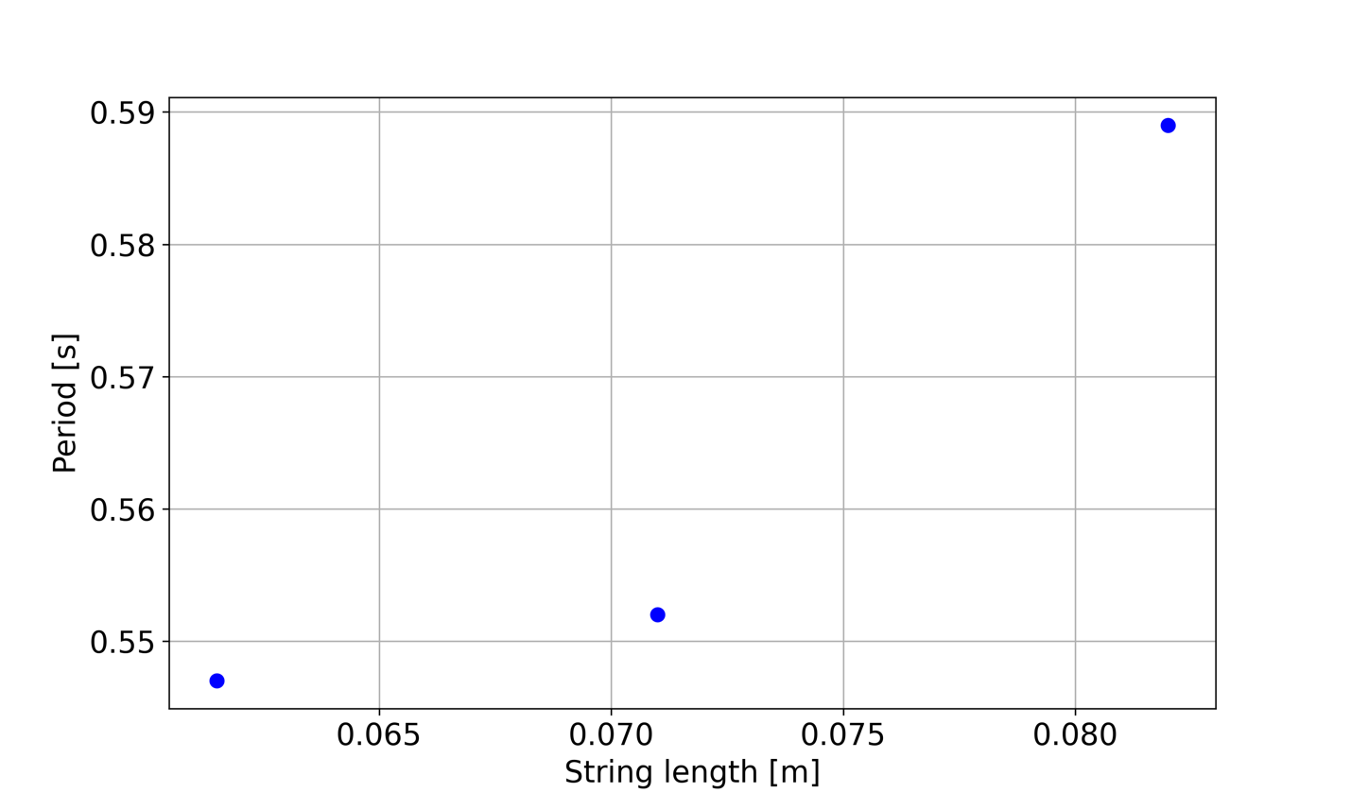

Figure - Pendulum Period as function of string length

**Experiment 00004**

in this experiment we change the mass and see how the period changes as a function of the mass weight.

1. Mass weight is: ____ kg
2. The mass is perpendicular to the table
3. String length:
   1. String 1 is 0.08 ± 0.005 meters
   2. String 2 is 0.075 ± 0.005 meters
   3. The height from the mass to the contact point in perpendicular line is 0.07 meters ± 0.002 meters
4. Angle between the strings is:
   1. Between string 1 and a perpendicular line to the mass is 35 ± 10 deg
   2. Between string 2 and a perpendicular line to the mass is 45 ± 10 deg
5. Mass width: 0.017 ± 0.001 meters

|  |  |  |
| --- | --- | --- |
| Experiment number | Mass [kg] | Period [s] |
| 00004_01 | 1 | .568 |
| 00004_02 | 1 | .551 |
| 00004_03 | 1 | .578 |
| 00004_04 | 1 | .585 |
| 00004_05 | 1 | .544 |
| 00004_06 | 1+2 | .535 |
| 00004_07 | 1+2 | Bad data |
| 00004_08 | 1+2 | .547 |
| 00004_09 | 1+2 | .561 |
| 00004_10 | 1+2 | Bad data |
| 00004_11 | 1+2 | Bad data |
| 00004_12 | 1+3 | Bad data |
| 00004_13 | 1+3 | .580 |
| 00004_14 | 1+3 | .559 |
| 00004_15 | 1+3 | .570 |
| 00004_16 | 1+3 | .578 |
| 00004_17 | 1+3+4+5 | .578 |
| 00004_18 | 1+3+4+5 | .585 |
| 00004_19 | 1+3+4+5 | .572 |
| 00004_20 | 1+3+4+5 | .590 |
| 00004_21 | 1+3+4+5 | .592 |
| 00004_22 | 1+3+4+5+6+7 | .542 |
| 00004_23 | 1+3+4+5+6+7 | .589 |
| 00004_24 | 1+3+4+5+6+7 | .590 |
| 00004_25 | 1+3+4+5+6+7 | .559 |
| 00004_26 | 1+3+4+5+6+7 | .576 |

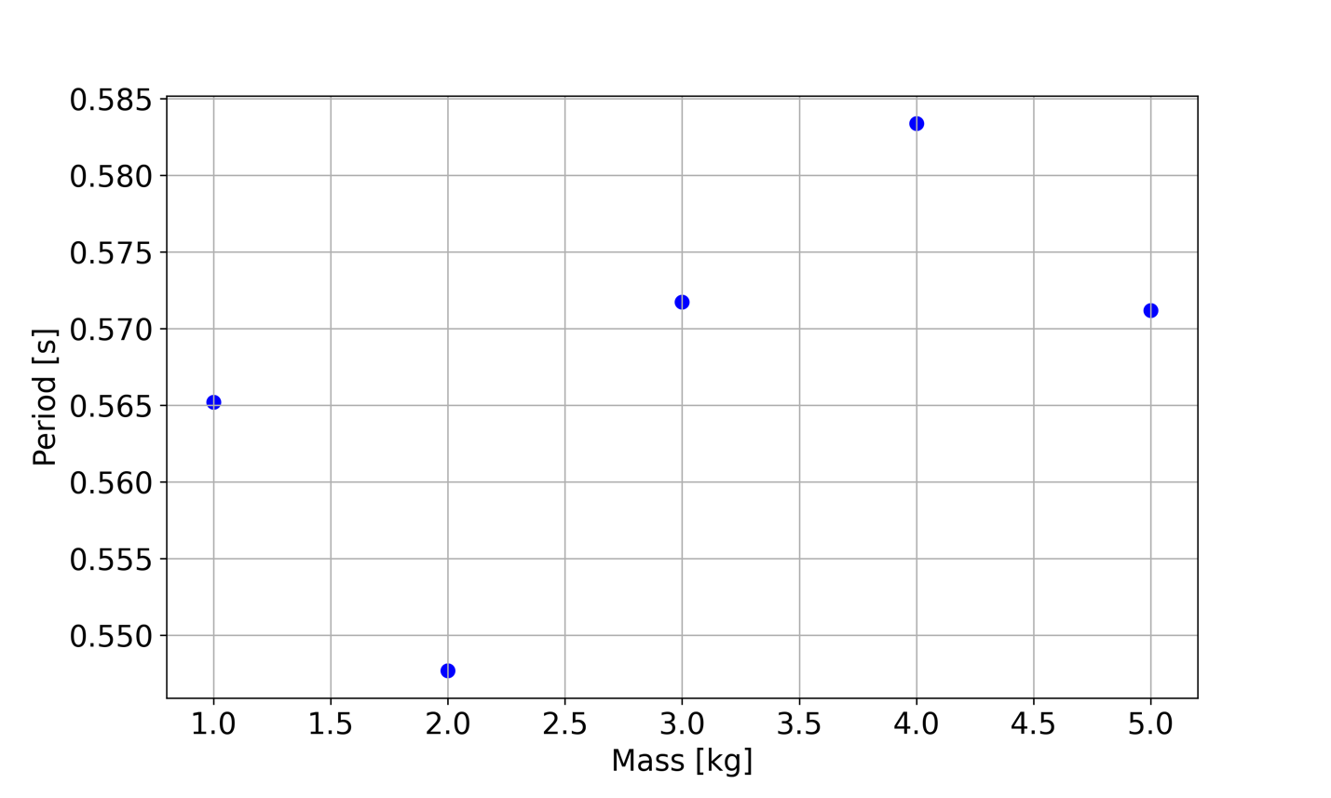

Figure - Period as a function pendulum mass

$$T=2π\sqrt{\frac{l}{g}}$$

**Experiment 00005**

The experiment is done at the super pendulum at Weizmann.

Insert pictures

In experiment 00005 we change the mass release angle. We measure the period as a function of the release angle.

1. Mass weight is: 57 kg (see supplemental materials at the end for the assessment procedure)
2. The mass is perpendicular to the floor
3. String length: 36 m 0.001 meters
4. Mass width: 0.008 ± 0.001 meters that crosses our IR beam

|  |  |  |  |
| --- | --- | --- | --- |
| Experiment number | X distance of mass from center [m] | Angle of release [deg] (independent variable) | Period [ms] (dependent variable) |
| 00005_01 | 0.1 | 0.18±0.03 | 11110 |
| 00005_02 | 0.1 | 0.18±0.03 |  |
| 00005_03 | 0.1 | 0.18±0.03 |  |
| 00005_04 | 0.2 | 0.36±0.06 |  |
| 00005_05 | 0.2 | 0.36±0.06 |  |
| 00005_06 | 0.3 | 0.55±0.09 |  |
| 00005_07 | 0.3 | Failed | Weight almost hit our detector, experiment aborted |
| 00005_08 | 0.3 | 0.55±0.09 |  |
| 00005_09 | 0.4 | 0.73±0.12 |  |
| 00005_10 | 0.4 | 0.73±0.12 |  |
| 00005_11 | 0.5 | 0.91±0.15 |  |
| 00005_12 | 0.5 | 0.91±0.15 |  |

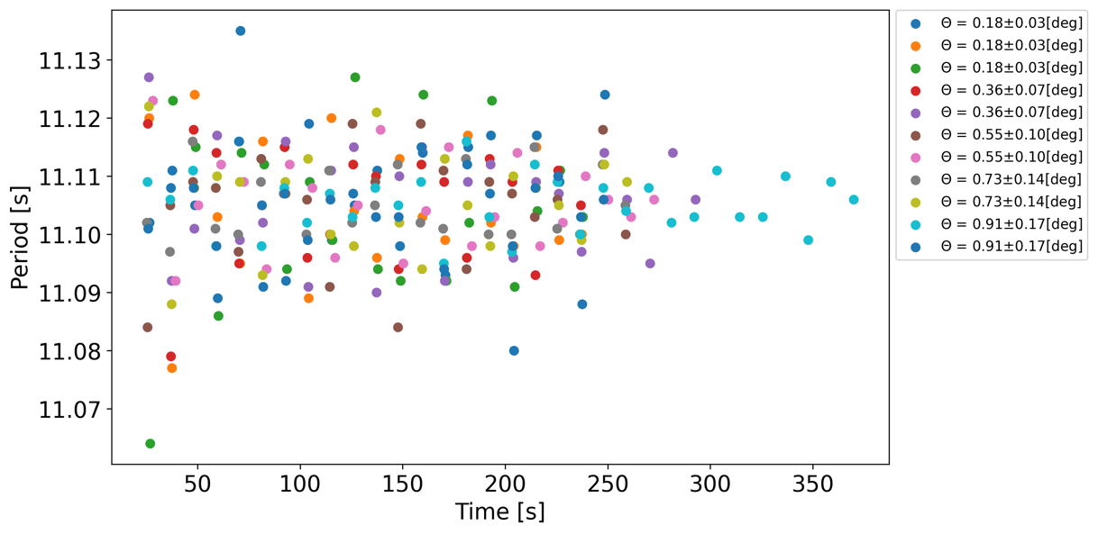

Figure 11 - Period vs Time in Super pendulum experiment

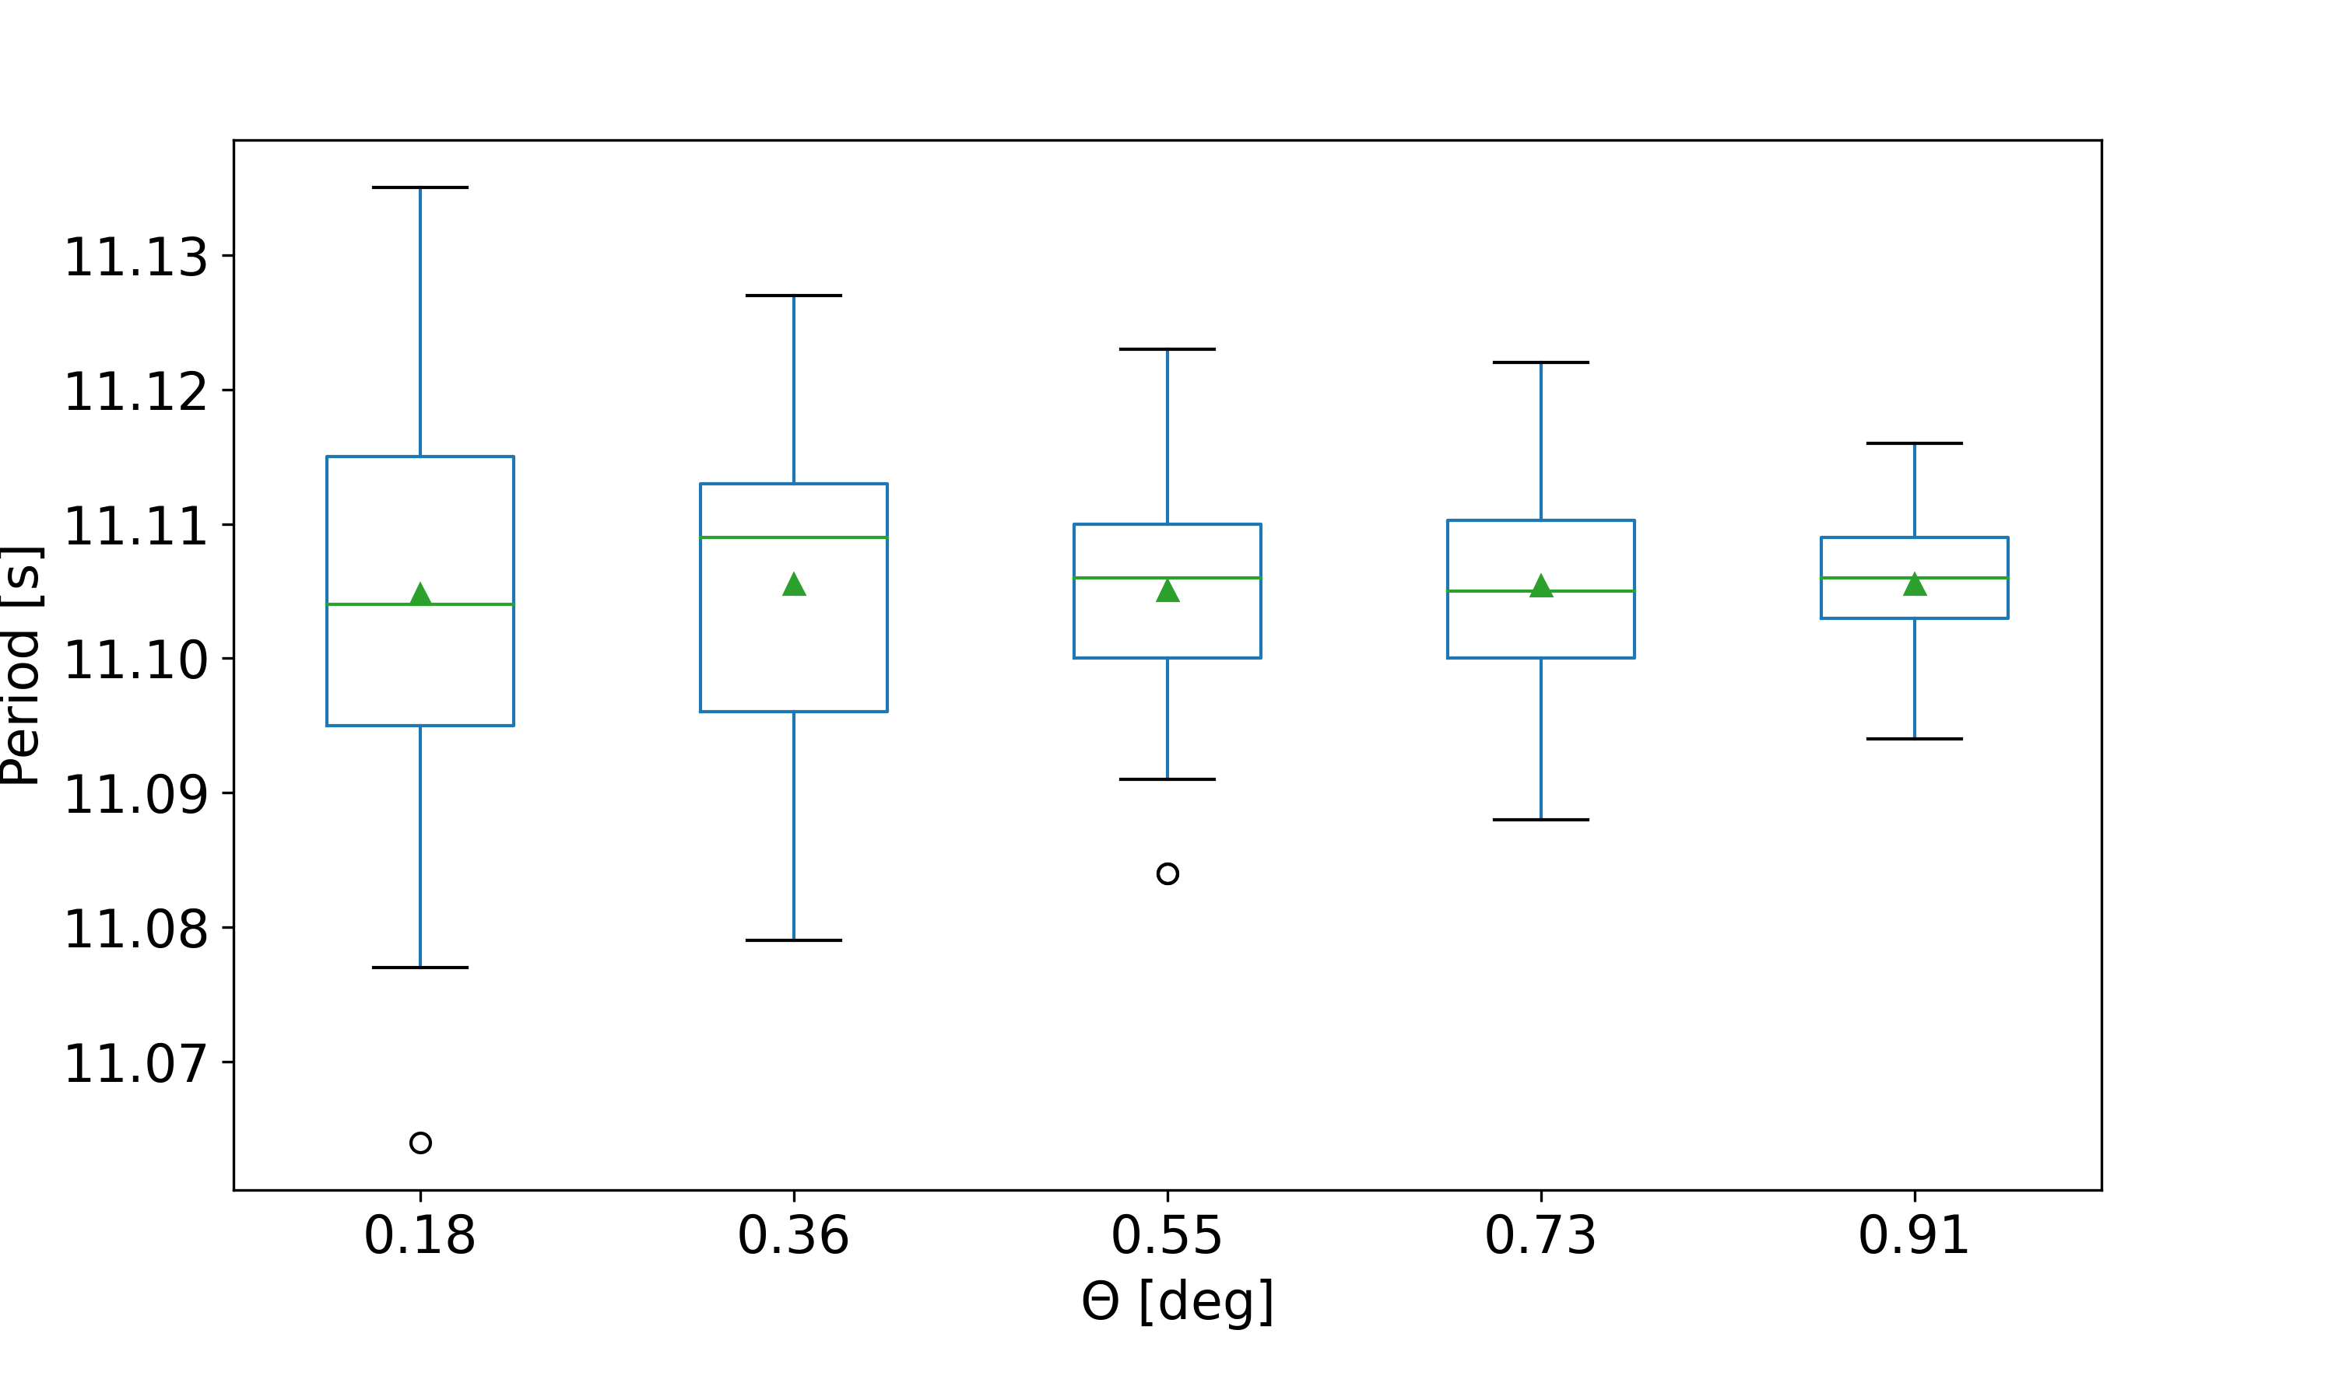

Figure 12 - Period vs. Theta (angle of release) [deg]

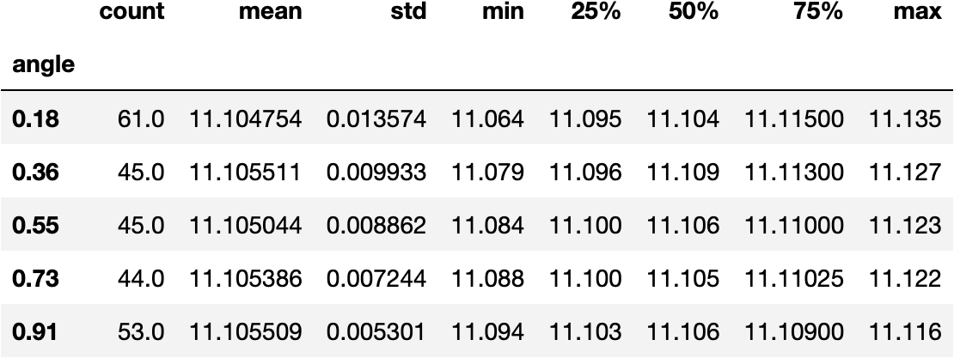

Table 1 - Period statistics as function of angle of release

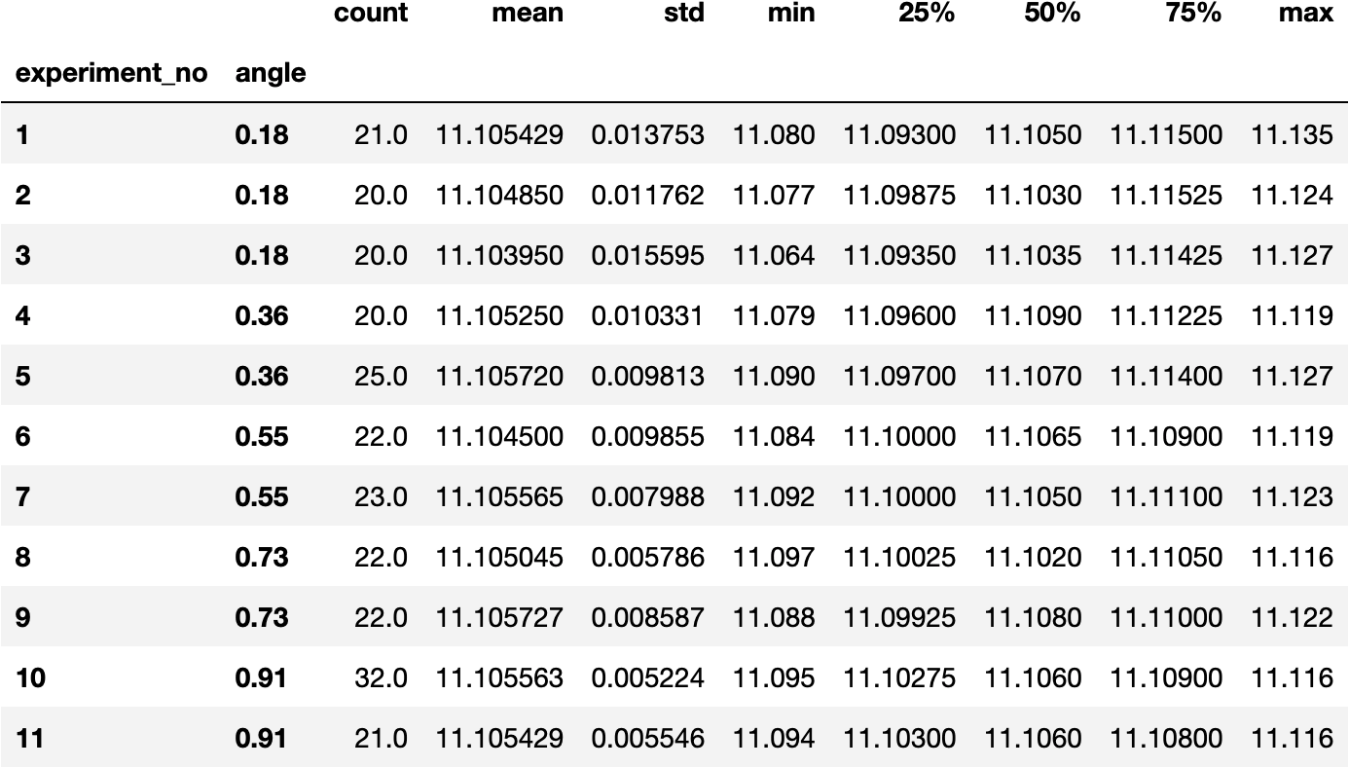

Table 2 - Period Statistics per experiment number and angle of release

**How we assessed the Foucault pendulum mass?**

We used the image below which was taken on site to assess the mass of the pendulum. We measured in pixels and with a ruler Eitan’s hand and used these measurements to convert pixels into meters. We then measured the height and diameter of the mass. We found that the height is approximately 0.2m and the diameter is about 0.2m as well. We also assumed that mass was made of iron. Iron density is approximately 7.874 gm/cm^3. The mass volume was calculated from pi*r^2 * h= 0.0073m^3. From we calculated the mass to be approximately 57 kg by multiplying the volume with the iron density.

**h** = 0.21*m

**r** = 0.21/2*m

**V** = h*pi*r^2**=>** 0.0073 m^3

We found that Eitan’s hand length is 121 pixels and using a ruler we measured it to be 0.185m. the height and diameter of the mass was measured to be of around 136 pixels. Using this information we converted height and diameter from pixels to meters.

Diameter = h = 136*0.185/121*m**=>** 0.2079 m

Assuming the weight was made of iron whose density is 7.874 g/cm^3, the mass of this pendulum is

**iron_density** = 7.874 *gram/(cm^3)

V**=>** 0.0073 m^3

Pendulum_mass = V * iron_density in kg**=>** 57.2721 kg

